Testing of battery power monitoring circuit

For the testing if the power monitoring the equipment I will be using is the; Agilent triple power supply, the Tektronix Digital Multi-Meter. I’m using the triple power supply to supply the power to the circuit. I am also using it to vary the voltage to see when the switch of the LEDs happens. This way I can measure the amount of voltage of when the green LED is on and off, which tells me the threshold voltage. The digital multi-meter is used for trouble shooting and making sure each component has the right amount of voltage going to it. During the first trial of testing I set up the original circuit that was created for the power monitoring of the battery. Using the 4.3V Zener diodes, 1K resistors and a NPN BJT we could successfully light up the green LED that notifies when the battery is fully charged and is supplying enough power to the circuit. When supply the voltage to the circuit and having the green LED turn on, we then wanted to vary the voltage to see at what voltage the green LED would turn off. We got a measurement of about 5.32V of when the green LED would turn off. Once the voltage supply is below the approximated voltage threshold the red LED should turn on. However, when we first tested the circuit and we got the green LED to turn on, I then lowered the voltage below that threshold when the BJT should switch off and the red LED would turn on, but that did not happen. It turned out that the BJT was damaged so I had to reconfigure the circuit to work with a JFET N-Channel, and we successfully got the red LED to turn on. However, we had a problem with the red LED being on the whole time even whole the green LED was on, and this was not what we wanted to accomplish. We want to be able to switch from the green LED to the red LED when the supplied voltage by the batter is running low.

To fix this we switched out the transistor one last time and reconfigured the circuit one last time as well. We switched out the JFET with a 2N4401 NPN BJT, this finally gave use the result we were looking for you, however this circuit would give us 3 different types of status of the voltage of the battery, which will be describe later. There was a few trial and errors during the process of testing of this battery status indicator circuit. However, half of those errors were human and equipment errors; for example, the circuit not being fully connected to power, a poor connection between the triple power supply and the breadboard, missing a certain connection between components on the breadboard, or a part of the circuit not being properly grounded. Some of the other trial and tribulations that were a part of the testing was due to the transistors within the circuit. Another difficulty with the testing of this circuit was the accessibility of some of the components like the BC547 BJT. Trying to find this specific BJT was difficult, and since the number of stores that could possibly have it were limited. As well as ordering that specific component online and waiting for it to be delivered would waste time that was needed for the testing of the circuit. The reason for this circuit is to give us the status of the battery life within the fire alarm system itself. While the battery is being charged, because discharge can happen or a poor connect may happen and the battery life may run low. So, we want to make sure if it is that we can either check the connection or change the battery. Also, if the battery isn’t being charged and is in use we want to monitor the life of the battery as well to make sure we know when the battery is low so the proper accommodations can be made to the fire alarm system. The table below shows a comparison table between the different types of transistors we used.

The battery status indicator will monitor the life of the battery that is in the system. Since we will be using a 9V battery this circuit will monitor the life of the 9V battery that is in the system. So, when the battery is fully charged the green LED will light, and this light indicates that the battery is fully charged at 9v. The one green LED lighting up will also tell us that the voltage from the battery coming in is above 5V. When the battery voltage drops to about 7V the green LED will remain on, however now the red LED will turn on. These two LEDs being on at the same time tells us the status of the battery. Now when both LEDS are on that the battery has gotten moderately lower than before, however the output voltage is still above the 5V threshold. This second indication from the LEDs helps us realize to keep watch of the battery since the voltage has decreased from being fully charged. Once the voltage of the battery has dropped between 5.32V – 5V, then the green LED will turn off while the red LED remains to stay lit. This next indication helps us establish that the battery power is now low within the fire alarm system, and with this information we can either charge the battery back to the main voltage or change the battery out with a new battery. Nonetheless, if the battery hasn’t been changed and the voltage from the battery has dropped down between 3.34V – 2.74V, then both the green LED and the red LED will be off. If both LEDS are off, then this is a clear indication that the battery in the fire alarm system needs to be changed. Other methods have been used to determine the life status of batteries within a system. We chose this method because of the simplicity of the circuit. Also, the cost was also very cheap since this circuit didn’t require a lot of components to be involved in it. The two figures show when the voltage is around 7V and both LEDs are on, and when the battery has reached about 5V and only the red LED is on.

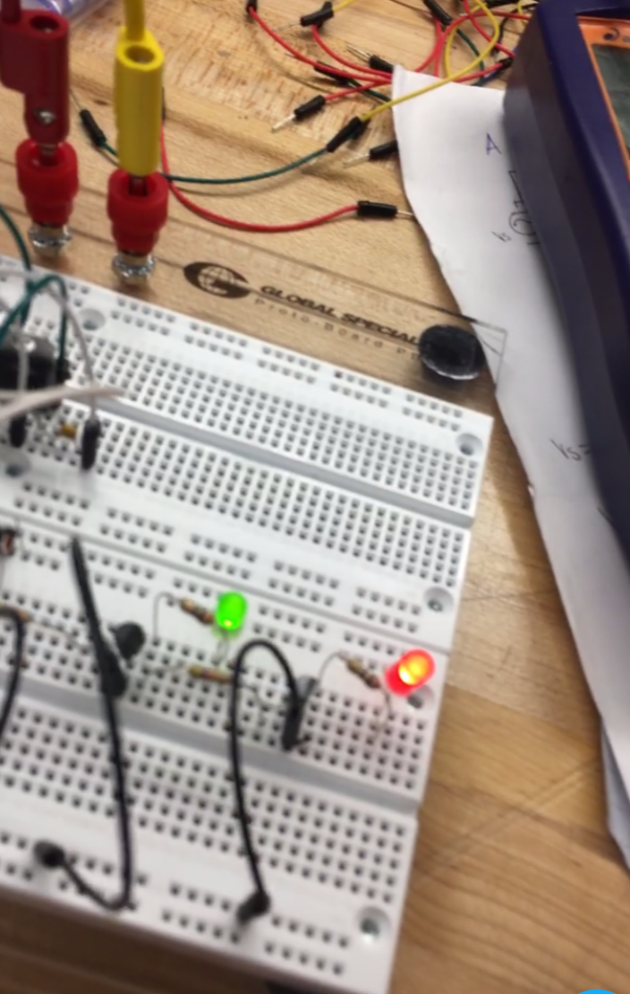 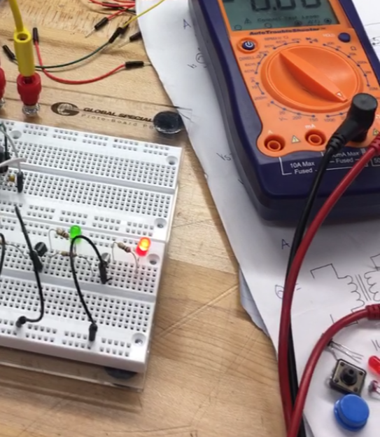

Testing of the power source circuit

For the testing if the AC to DC power monitoring circuit the equipment I will be using is the; Tektronix AFG 3022B Function Generator, the Tektronix Digital Multi-Meter. I’m using the Tektronix AFG 3022B Function Generator to supply the AC power to the circuit. I am also using it to vary the Amplitude to see when the switch of the LEDs happens. As well as using the function generator to vary the frequency to see how that effects the circuit. Using the function generator as well as the digital multi-meter I can measure the amount of voltage that is supposed to be at the output of the circuit. The digital multi-meter is also used for trouble shooting and making sure each component has the right amount of voltage going to it. During the first trial of testing I set up the original circuit that was created for the AC to DC power monitoring and charging of the battery. Using the four 1N4007 diodes, one 100uf and two .01uf capacitors and a 9V regulator we could successfully get the right amount of voltage at the output of the circuit. After receiving the correct voltage output, I wanted to interchange the 100uf capacitor to see if would make different in the output, and if it did was a significant one or not. Once doing this I realized it did make difference in the output but it is very insignificant. I then connected the circuit to the battery status indicator circuit and we were able to light up the green LED that notifies when the battery is fully charged and is supplying enough power to the circuit. I then started to vary the amplitude of the function generator which in turn varied the voltage. Doing this we could see the two LEDs switching on and off. When doing this, we got a measurement of about 5V of when the green LED would turn off; which was the same measurement that was obtained before from testing the status circuit from earlier. When lowering the amplitude of the AC source which in turn lowered the output voltage, we could see when the red LED turned on. The testing of this circuit went well and we got the results that we assumed to get.

There was a few trial and errors during the process of testing of this AC to DC charging and power monitoring circuit. However, half of those errors were human and equipment errors; for example, the circuit not being fully connected to power, a poor connection between the function generator and the breadboard, missing a certain connection between components on the breadboard, or a part of the circuit not being properly grounded. Some of the other trial and tribulations that were a part of the testing was due to the capacitors within the circuit. Another difficulty with the testing of this circuit was the accessibility of some of the components like a certain capacitance that was needed. Trying to find this specific capacitor was difficult. So instead of making a few capacitors parallel and making them add up to the number I needed, I just tested different ones to make sure that it had the same impact to the circuit. This method was the simplest way and time effective as well.

The reason for this circuit is ultimately to provide power to the fire alarm system. However, with this circuit we are using the AC voltage source is converting it to DC voltage so that the battery is being charged. We also want to consider that discharge can happen or a poor connect may happen and the battery may not get charged. So, while this circuit is powering the fire alarm system it is also charging the secondary power source as well. The AC to DC charging and power monitoring circuit is maintain the primary and secondary sources of power for the fire alarm system. Since we will be using a 9V battery this circuit will be supplying a DC voltage of about 9V to the battery that is in the system to charge it. So, while the battery is being charged it will supply the power to the fire alarm system. We will also have the battery status indicator circuit connect to the battery. So, while the battery is being charged the green LED will light, and this light indicates that the battery is fully charged at 9v. Even though the main purpose of this circuit is to supply the power to the fire alarm system, the crucial part is the charging of the battery. This is crucial to this circuit because if the battery isn’t charged then the system won’t be working. There is such a big emphasis on the battery being charged because it is the secondary power supply of the fire alarm system. By secondary power supply source, we mean that if something happens within the facility that the fire alarm system and the AC power supply, which is the primary power supply, is either cut off or interrupted then the battery come into play. So, while the primary power supply is unavailable the battery will then supply the power to the system. Now during this time that the primary power supply is unavailable, and the secondary power supply is providing the power to the fire alarm system, this is when the battery status monitoring circuit will come into play. Because if the primary power is out for a while this circuit will let us know if the battery starts to gets low or not. Other methods have been used for switching between the primary power source and the secondary power source. We chose this method because of the simplicity of the circuit. Also, the cost was also very cheap since this circuit didn’t require a lot of components to be involved in it. The figure below shows the AC to DC circuit while connected to the battery status indicator circuit. In the figure the red LED is on because at the time I was varying the amplitude of the function generator.

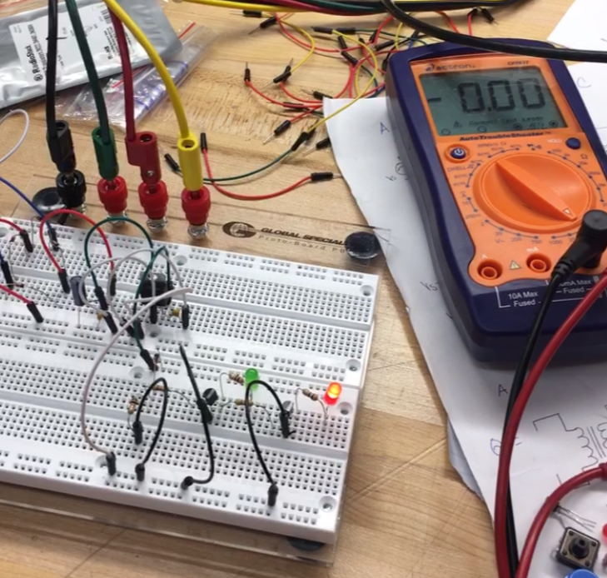

Sounder comparison

|  |  |
| --- | --- |
| Sounder | Specs |
| PS1927P02 Piezo sounder | Sound pressure (min): 90 dBA/10cm  Frequency (kHz): 2.7  Input Voltage (Rectangular wave): 10Vp  Waterproof, High sound pressure, good for potted circuits |
| PS1920P02 Piezo sounder | Sound pressure (min): 80 dBA/10cm  Frequency (kHz): 2  Input Voltage (Rectangular wave): 10Vp  Low frequency tone, good for potted circuits |
| PS1740P02E Piezo sounder | Sound pressure (min): 75 dBA/10cm  Frequency (kHz): 4  Input Voltage (Rectangular wave): 3Vp,  High sound pressure  Good for warning and alarm sounds |
| 12 VDC PUI programmable buzzer | Sound pressure (min): 100 dBA/10cm @ 1kHz tone  Frequency:100Hz – 6kHz  Input Voltage: 7 – 24VDC |

This table shows the comparison of the four different types of sounders we were considering for the fire alarm system. We chose to go with the PS1740P02E Piezo sounder, because we felt like it was the best fit for the type of system we were trying to accomplish. This sounder has one of the best sound pressure specs that we wanted, because it wasn’t too low, but just high enough to where it would be over powering. Even though the frequency was high than the most of the choices we had it was still a good range when compared to a lot of other factors as well. What also was good with this sounder was that peak voltage wasn’t too high so it wouldn’t consume too much power within the fire alarm circuit. As well as this type of sounder is a good match for a system that need some type of alarm or warning sound, which was what we were looking for so that’s why this sounder was a good choice for us.

Battery comparison

|  |  |
| --- | --- |
| Battery type | Summary |
| Alkaline | Good for low drain devices, okay for hi-drain devices, cheap, long shelf life, decent for smoke detector use, capacity: 2400mAh, low self-discharge |
| Carbon Zinc, Zinc Chloride | Good for very low drain devices, poor for hi-drain devices, cheap, long shelf life, okay for smoke detectors, capacity: 500 – 1100mAh, low self-discharge |
| Nickle-Zinc (NiZn) | Short cycle life, good for devices with extra voltage, not good for smoke detectors, a little pricey, fast self-discharge, capacity: 600 – 1000mAh |
| Lithium | Powerful, Great for smoke detectors, good for low drain devices, high price, long shelf life, slow self-discharge, capacity: 2100 – 3000mAh |

The two main types of batteries that we had to choose from was the alkaline and the lithium battery. From the comparison table, you can see that they both have very similar specs compared to one another. It was hard to choose between the two, but we chose to go with the lithium battery since the capacity had a larger range than the alkaline battery. Also, even though they both have a long shelf life the lithium battery’s shelf life was a lot longer and the self-discharge is at a lower percent within the lithium battery than the alkaline battery. The NiZn battery wasn’t a good choice because it had such a short life cycle, the capacity of that type of battery is very low, and it doesn’t work well with low drain devices like smoke alarms.